Class Time:
Names:

Discrete Random Variables: Discrete Distribution Lab II

Student Learning Outcomes:
- The student will compare empirical data and a theoretical distribution to determine if a Tet gambling game fits a discrete distribution.
- The student will demonstrate an understanding of long-term probabilities.
Supplies:
- 1 game “Lucky Dice” or 3 regular dice
Note: See #14 in the homework for a detailed game description.
Note: Round relative frequencies and probabilities to four decimal places.
The Procedure
- The experiment is to bet on one object. Then, roll 3 Lucky Dice and count the number of matches. The number of matches will decide your profit.
- What is the theoretical probability of 1 die matching the object? ___________
- Choose one object to place a bet on. Roll the 3 Lucky Dice. Count the number of matches.
- Let X = number of matches. Theoretically, X ~ B(_____,______)
- Let Y = profit per game.
Organize the Data
- In the chart below, fill in the Y value that corresponds to each X value. Next, record the number of matches picked for your class. Then, calculate the relative frequency.

x | y | frequency | relative frequency
0
1
2
3
- Calculate the following
- = _______
- s_{x} = _______
- = _______
- s_{y} = _______
- Explain what represents.

- Explain what represents.

- Based upon the experiment:
- What was the average profit per game? _________
- Did this represent an average win or loss per game? ________
- How do you know? Answer in complete sentences.

- Construct a histogram of the empirical data.

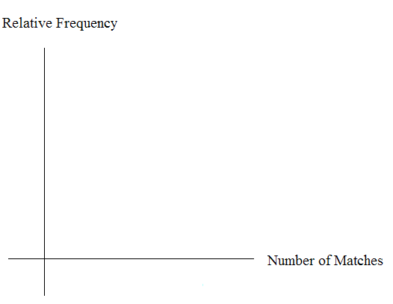

Theoretical Distribution

- Build the theoretical PDF chart for X and Y based on the distribution in Part 1.
x | y | P(X = x) = P(Y = y)
0
1
2
3

- Calculate the following
- μ_{x} = _______
- σ _{x} = _______
- μ_{y} = _______
- Explain what μ_{x} represents.

- Explain what μ_{y} represents.

- Based upon theory:
- What was the expected profit per game? _________
- Did the expected profit represent an average win or loss per game? ________
- How do you know? Answer in complete sentences.

- Construct a histogram of the theoretical distribution.

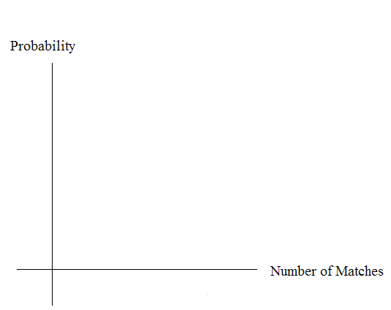

Use the Data
Calculate the following (rounded to 4 decimal places):
NOTE: RF = relative frequency
Use Information from “Theoretical Distribution” here:
- P(X = 3) = _______
- P(0 < X < 3) = _______
- P(X ≥ 2) = _______
Use information from “Organize the Data” here:
- RF(X = 3) = _______
- RF(0 < X < 3) = _______
- RF(X ≥ 2) = _______

Discussion Questions

For questions 1. and 2., consider the graphs, the probabilities and relative frequencies, the means and the standard deviations.

- Knowing that data vary, describe three similarities between the graphs and distributions of the theoretical and empirical distributions. Use complete sentences.

- Describe the three most significant differences between the graphs and distributions of the theoretical and empirical distributions.

- Thinking about your answers to 1. and 2., does it appear that the data fit the theoretical distribution ? In 1 - 3 complete sentences, explain why or why not.

- Suppose that the experiment had been repeated 500 times. Which table (from “Organize the Data” and “Theoretical Distribution”) would you expect to change? Why? How might the table change?

